12/29/2019 Insights on ERP

**What is an ERP?**

An ERP (Enterprise Resource Planning) software is a one which helps organizations to organize and manage day-to-day activities such as hiring, project management, human resources, and accounting. The core construct of this system is that it is designed around a common database, ensuring that an information is “normalized” across the entire enterprise. This helps in connecting systems and the people who use them. In simple terms, ERP is a hub for integrating people, systems and technologies across an enterprise.

**Business activities in an enterprise**

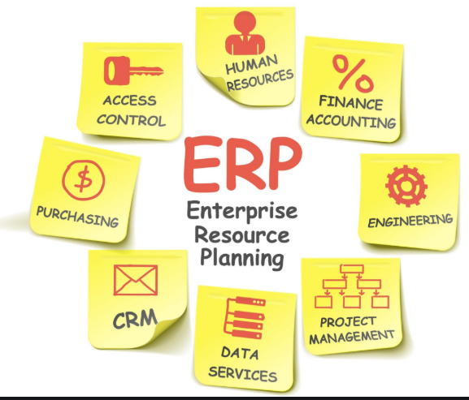

**History**

* ERP started off on a paper-based organizing system which than evolved to the use of computers and large machines in server rooms.
* Personalization of the system to meet specific needs became a major requirement for growing businesses, but the cost for upgrading was high.
* As the New Millennium approached the cost of implementing ERP’s increased.
* As a solution, an ERP software was developed to be used with the help of just an internet connection
* The storage solution was the cloud which not only made the upgrades easier and of little cost but also increased the safety of the information.

**Examples**

1. JD Edwards
2. Oracle E-Business Suite
3. Microsoft Dynamics 365
4. SAP ERP

**Architecture**

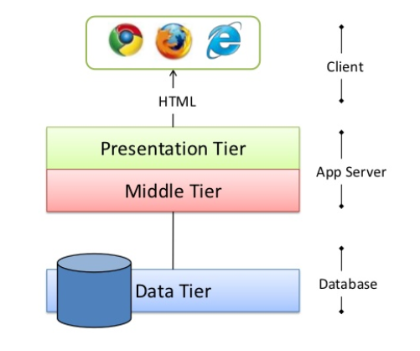

**Technologies by tier**

* Presentation Tier: HTML, CSS, JavaScript
* Middle Tier: Ruby on Rails, PHP, JSP, ASP, Python
* Data Tier: My SQL, Microsoft SQL, Oracle DB

12/30/19 **Introduction to Q Software**

Q Software is a software that helps in the auditing of ERP systems, such as, JD Edwards EnterpriseOne, JD Edwards World, and Oracle E-Business Suite that are used by organizations around the world. For example, if a particular employee in an ERP system has only one task to be completed by him(Financing), but because of some error has been assigned two tasks(Financing and Project management), the Q Software identifies that error and reports it to the auditing team.

The auditing team then perform the required action. This helps an organization maintain a clean record of all the data/information that is stored in an ERP system.

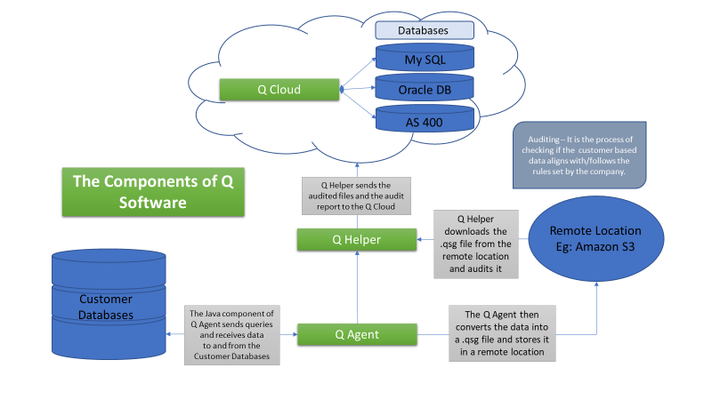

**Introduction to GitHub**

Git is a system for tracking changes in computer files. It enables multiple developers can work on the same project without having to be in the same network.

GitHub is a remote repository to which a developer push the repositories created/changed in one’s own local repository.

I learnt few basic git commands:

1. git status 🡪 for looking at files that are currently staged
2. git commit 🡪to save all the files in a local directory
3. git add <file name> 🡪to add a new file to the git repository
4. git push origin <branch name> 🡪 for our code to be viewed by other developers in git